**CSE102L Computer Programming Lab**

**LAB # 5**



**2020**

**Submitted to:**

**Engr. Abdullah Hamid**

**Submitted by:**

**TAYYABA**

**Registration No :**

**19PWCSE1854**

**Semester: 2nd**

**Class Section:** **C**

“On my honor, as student of University of Engineering and Technology,

I have neither given nor received unauthorized assistance on this

academic work.”

JUNE 17 , 2020

**Department of Computer Systems Engineering**

**University of Engineering and Technology, Peshawar**

## **Objectives:**

## To understand the programming knowledge using Array

1. To understand the programming using array

**Question no 1:**

1. Write a program to input twelve numbers from user using array and display all values on console (3 values in a row) (use separate loops for input and output operation).

SAMPLE OUTPUT:

Value 1=?? Value 2=?? Value 3=??

Value 4=?? Value 5=?? Value 6=??

Value 7=?? Value 8=?? Value 9=??

Value 10=?? Value 11=?? Value 12=??

**Program:**

**#include<iostream>**

**using namespace std;**

**main()**

**{**

**int x[12];**

**int k=1;**

**for(int i=1;i <= 12;i++)**

**{**

**cout<<"Enter value "<<i<<" ";**

**cin>>x[i];**

**}**

**for(int i=1;i <= 4;i++)**

**{**

**for(int j=1;j<=3;j++)**

**{**

**cout<<"Value "<<k<<" = "<<x[k]<<"\t";**

**k++;**

**}**

**cout<<endl;**

**}**

**getch();**

**}**

**Output:**

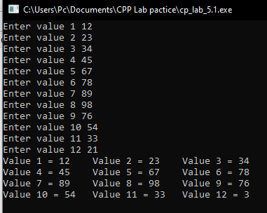

**Question no 2:**

1. Write a program to input ten numbers from user using array and find the average of numbers (use separate loops for input operation and calculation).

**Program:**

**#include<iostream>**

**using namespace std;**

**main()**

**{**

**float x[10];**

**float avg,sum=0;**

**for(int i=1; i<=10; i++)**

**{**

**cout<<"Enter number " << i <<" = ";**

**cin>>x[i];**

**cout<<endl;**

**sum=sum + x[i];**

**}**

**avg=sum/10;**

**cout<<" Average of ten numbers is = "<<avg;**

**getch();**

**}**

**Output:**

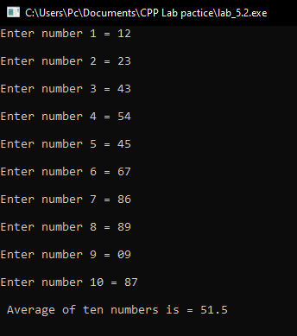

**Question no 3:**

1. Write a program to input multiple values from user using array and find the maximum (use separate loops for input operation and calculation).

**Program:**

**#include <iostream>**

**using namespace std;**

**int main()**

**{**

**int i;**

**float arr[100];**

**for(i = 1; i <= 10; i++)**

**{**

**cout << "Enter Number " << i << " : ";**

**cin >> arr[i];**

**}**

**for(i = 1;i <= 10; i++)**

**{**

**if(arr[0] < arr[i])**

**arr[0] = arr[i];**

**}**

**cout << "Largest number is = " << arr[0];**

**}**

**Output:**

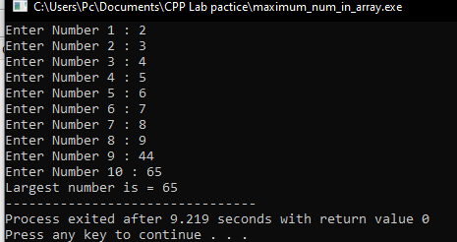

**Question no 4:**

1. Write a program to input two arrays from user and find the sum of arrays (element by element).

**Program:**

**#include<iostream>**

**using namespace std;**

**main()**

**{**

**int x[5],y[5],sum=0;**

**for(int i = 1; i <= 5; i++)**

**{**

**cout<<"Enter the number"<<i<<" for First array = ";**

**cin>>x[i];**

**}**

**cout<<"********************************************""\n\n";**

**for(int i = 1; i <= 5; i++)**

**{**

**cout<<"Enter number "<<i<<" for Second array = ";**

**cin>>y[i];**

**}**

**cout<<"********************************************""\n\n";**

**for(int i = 1; i <= 5; i++)**

**{**

**sum=x[i] + y[i];**

**cout<<"The sum of "<<x[i] <<"+"<< y[i]<<" is "<<sum<<endl;**

**}**

**}**

**Output:**

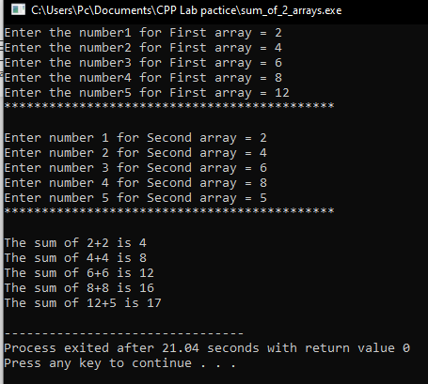

**Question no 5:**

1. Write a program to input array from user and display the elements of array in reverse order (use separate loops for input and output operation).

SAMPLE OUTPUT:

Input = 1, 2, 3, 4, 5

Output = 5, 4, 3, 2, 1

**Program:**

**#include <iostream>**

**using namespace std;**

**main()**

**{**

**int a[10];**

**int i;**

**cout<<" Enter array elements = "<<endl;**

**for (i = 1; i <= 10; i++)**

**cin>>a[i];**

**for (i = 10; i >= 1; i--)**

**cout<<"reverse numbers are = "<<a[i]<<endl;**

**return 0;**

**}**

**Output:**

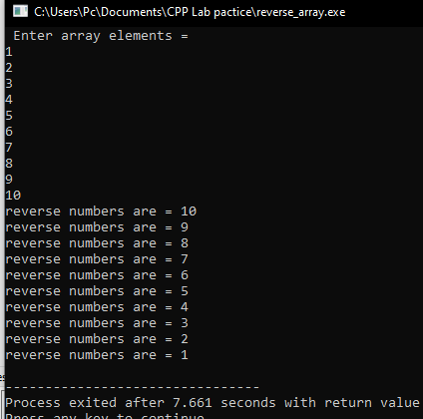

**Question no 6:**

1. Write a program to input multiple values from user using array and then ask user to input a key number and then compare it with values entered by user(for array) and then display the index number of array with which value get matched (use seperate loops for input operation and calculation) (use different loops for input operation and calculation).

**Program:**

**#include<iostream>**

**using namespace std;**

**main()**

**{**

**int x[5], key;**

**for(int i = 1; i <= 5 ; i++)**

**{**

**cout<<"Enter number "<<i<<" = ";**

**cin>>x[i];**

**}**

**cout<<"\nEnter Key_Number : ";**

**cin>>key;**

**for(int j = 1; j <= 5; j++ )**

**if(x[j] == key)**

**{**

**cout<<"Your Key matched with "<<x[j]<<" and index "<<j<<" of the array\n\n";**

**}**

**else**

**{**

**cout<<"The key doesnt match with any index of array";**

**}**

**return 0;**

**}**

**Output:**

